A

PROJECT REPORT

ON

**"PROGRESS PILOT"**

As A Partial Requirement for the Degree of

BACHELOR OF COMPUTER APPLICATIONS

(B.C.A)

Submitted To



**C.B PATEL COMPUTER COLLEGE &**

**J. N. M. PATEL SCIENCE COLLEGE,**

**BHARTHANA, VESU, SURAT.**

Affiliated To

**VEER NARMAD SOUTH GUJARAT UNIVERSITY, SURAT.**

**ACADEMIC YEAR: 2023 – 2024**

**GUIDED BY: SUBMITTED BY :**

Asst. Pro. Maulik Chudawala Jay A. Sopariwala

Diya P. Presswala

Isha P. Jariwala

**Acknowledgement**

When we reach the completion of the project, giving credit becomes a must, as without the support of other so many people's help and guidance, this project could not be completed successfully.

I would like to express my heartfelt gratitude to **“ASST. PROF. MAULIK CHUDAWALA”** for his invaluable guidance and support throughout the preparation of this project report on **“PROGRESS PILOT”** His expertise, encouragement, and insightful feedback have been instrumental in shaping this document.

I am also deeply indebted to the faculty and staff of **“C B PATEL COMPUTER COLLEGE & J. N. M. PATEL SCIENCE COLLEGE”** and **“ASST. PROF. & HOD DHANANJAY PATEL”** for providing a conducive learning environment and resources essential for conducting this research and preparing the project report.

Furthermore, I extend my sincere appreciation to my peers and colleagues for their constructive criticism and suggestions, which have significantly enriched the content of this report.

Last but not least, I would like to thank my family for their unwavering support and understanding during the entire duration of this project.

Sincerely,

Jay A. Sopariwala

Diya P. Presswala

Isha P. Jariwala

**INDEX**

|  |  |  |
| --- | --- | --- |
| SR NO. | **DESCRIPTION** | PAGE  NO. |
| 1. | Introduction | 4 |
| 2. | Project Profile | 6 |
| 3. | Objectives | 8 |
| 4. | Project Category | 10 |
| 5. | Environment Description | 12 |
| 6. | Analysis Report | 14 |
|  | 6.1Current System | 15 |
|  | 6.2Limitations of Current System | 15 |
|  | 6.3Requirement Specification | 16 |
|  | 6.4Proposed System | 17 |
|  | 6.5Advantages of Proposed System | 17 |
|  | 6.6Use Case |  |
|  | 6.7DataFlow Diagram | 18 |
|  | 6.8Process Specification | 27 |
|  | 6.9Data Dictionary | 29 |
|  | 6.10Table Structures with Relationship | 32 |
| 7. | Design Report | 37 |
|  | 7.1SiteDiagram /Program Flow Diagram | 38 |
|  | 7.2Algorithms /Flow Chart | 39 |
|  | 7.3Security Issues | 40 |
|  | 7.4InputScreen Layouts | 41 |
|  | 7.5 Output Reports | 55 |
| 8. | Testing Report | 69 |
|  | 8.1TestCaseDesign | 70 |
|  | 8.2Testingissues | 73 |
| 9. | Limitation of the Proposed System | 75 |
| 10. | Future Enhancement | 77 |
| 11. | Justification of system as MIS and DSS | 79 |
| 12. | References | 81 |

**1.**

**Introduction**

## Introduction

**Welcome to Progress Pilot: Revolutionizing Project Progress Tracking**

Introducing Progress Pilot, a cutting-edge project progress tracking system designed to streamline the management process and enhance collaboration among stakeholders. Progress Pilot is a sophisticated platform built with innovation at its core. Leveraging the power of PHP, HTML, CSS, JavaScript, jQuery, AJAX, and Flutter, it offers a seamless and intuitive user experience across various devices and platforms.

**Empowering Administrators:**

The backbone of Progress Pilot lies in its administrative module. Administrators wield powerful tools to add, manage, and oversee faculty and head faculty details. Additionally, they have the capability to manage student group details with ease, ensuring smooth operations within the system.

**Empowering Head Faculty:**

Head faculty members play a pivotal role in the allocation and management of student groups. With the ability to allocate and oversee groups, they ensure optimal distribution and progress monitoring. Additionally, head faculty manage various categories of progress, ensuring projects stay on track towards success.

**Empowering Faculty:**

Faculty members are equipped with a comprehensive suite of features to manage group progress effectively. From attendance tracking to schedule management, faculty members can generate detailed progress reports, providing valuable insights for project improvement and refinement.

**Empowering Students:**

In the heart of Progress Pilot lies its dedication to student empowerment. Through the Flutter-based student module, students can register their group details, monitor progress given by faculty, and follow &access schedules effortlessly. Moreover, students have the ability to search for FAQs and request schedule changes, fostering open communication and collaboration with facultymember.

**2.**

**Project Profile**

**Project Profile**

|  |  |
| --- | --- |
| Project Title | PROGRESS PILOT |
| Project Type | WEB-MOBILE APPLICATION |
| Project Category | E-COMMERCE |
| Front End Technology | HTML ,CSS ,BOOTSTRAP ,FLUTTER |
| Back End Technology | PHP, DART, JQUERY, AJAX, JAVA SCRIPT |
| Data base | MYSQL |
| Development Tools | VS CODE, ANDROID STUDIO |
| Team Member | 3 |
| Project Duration | 3MONTHS |
| Project Guide By | ASSTPROF. MAULIK CHUDAWALA |
| Submitted To | C.B.PATELCOMPUTERCOLLEGE |
| Submitted By | JAY A.SOPARIWALA  DIYA P. PRESSWALA ISHA P. JARIWALA |

**3.**

**Objective**

## Objective

The main objective of our PROGRESS PILOT is to help faculties to easily manage their students project progress and students to monitors their performance.

* It offers Admin to manage faculty and head faculty details as well as manages students and it’s group details, view the groups allocated to the faculties.
* It also offers faculties to great functionalities such as scheduling, attendances, generate reports. We provide efficient, effortless and user-friendly functionalities.
* It offers Additional functions to the head faculty such as to allocate groups to the faculties, also manages the allocated groups and manages progress categories.
* Students are allows to use mobile application to monitors their progress, attendance, schedules given by their faculty.
* It also provides mobile application to faculties for easily manages their groups via smart phones because every time they have not their pc’s to manage things.

Progress Pilot is a new and innovative way to keep track of project progress. It has lots of great features, it's easy to use, and it's all about making sure everyone involved feels empowered and involved. Progress Pilot is here to change the way projects are managed in schools and colleges. Come along with us on this journey to work together better, be more efficient, and achieve success with Progress Pilot!

**4.**

**Project Category**

## Project Category

* Progress Pilot categorized into the Website as well as Mobile Application, means this is developed in the PHP technology for web and FLUTTER technology for app.
* Website& Mobile Application means this system is host onto the server and manages on the server and 24hourINTERNET facility is required.
* The database is stored on the server computer and managed by any computer and any validations or any scripts are executed on the server.
* The any verifications or any checking is done before send to database is done by the server only.
* In the web/mobile-based application, the workload on servers is slightly greater because they are responsible for the manageability of the system.
* The development of web/mobile-based application is considerable because security is much better than the desktop application.
* The management of database is much easier than managing single PC, means database is also stored on the server so it is the responsibility of server for managing it.

**5.**

**Environment Description**

## Environment Description

* **Hardware and Software Requirement**

|  |  |
| --- | --- |
| Technology | PHP, FLUTTER |
| GUI Tool Used | Microsoft visual Studio Code |
| Data base Server | My SQL |

* **The hardware and software required for developing a website are described below:-**

|  |  |
| --- | --- |
| Hardware Requirement | |
| Processor | IntelCOREi5 |
| Ram | 4GB |
| Hard disk | NO |

|  |  |
| --- | --- |
| Software Requirement | |
| Operating System | Windows 10 |
| Web Browser | Google Chrome |
| Software | Microsoft Visual studio Code ,My SQL |

**Technology Used**

Utilizing HTML, CSS, JavaScript, Bootstrap, PHP, and Flutter provides a comprehensive and versatile tech stack for developing a project management system with web and mobile capabilities. Here's how each technology can be leveraged:

1. **HTML (Hyper Text Markup Language)**

* HTML, or Hyper Text Markup Language, is the standard markup language for creating web pages and web applications.
* It provides a structure for content on the web, allowing developers to define the layout and appearance of web pages.
* HTML forms the structure of web pages in the project management system.
* It defines the layout, headings, paragraphs, forms, and other content elements.

1. **CSS (Cascading Style Sheets):**

* CSS, which stands for Cascading Style Sheets, is a fundamental technology used for styling web pages.
* It defines how HTML elements are displayed on a webpage, controlling their layout, appearance, and behavior.
* CSS enables web developers to create visually appealing and consistent designs across various devices and screen sizes.
* CSS is used for styling and formatting the HTML elements.
* It controls the colors, fonts, spacing, and overall visual appearance of the system's user interface.
* CSS is a powerful tool for web development, offering extensive capabilities for designing visually appealing and responsive websites.
* Mastery of CSS is crucial for creating modern and engaging user interfaces on the web.

1. **JavaScript:**

* JavaScript is a versatile and widely-used programming language primarily known for its role in web development.
* Initially created by Brendan Eich in 1995, JavaScript has evolved into a powerful language that is now supported by all modern web browsers.
* JavaScript adds interactivity and dynamic behavior to the project management system.
* It handles user interactions, form validations, and client-side data manipulation.

1. **Bootstrap:**

* Bootstrap is a popular open-source front-end framework for building responsive and mobile-first websites and web applications.
* Developed by Twitter, it provides a collection of CSS and JavaScript components, as well as pre-styled HTML elements, that help developers create consistent and visually appealing web interfaces quickly and efficiently.
* Bootstrap is a front-end framework that provides pre-designed UI components and layout utilities.
* It streamlines the development process by offering responsive design, grid system, and ready-to-use CSS classes.

1. **PHP (Hyper text Preprocessor):**

* PHP (Hypertext Preprocessor) is a widely-used, open-source scripting language primarily designed for web development.
* It was created by Danish-Canadian programmer Rasmus Lerdorf in 1994 and has since evolved into a powerful tool for building dynamic web applications.
* PHP is a server-side scripting language used for developing dynamic web applications.
* It handles server-side logic, database interactions, and backend processing in the project management system.

1. **Flutter:**

* Flutter is an open-source UI software development kit (SDK) created by Google.
* It allows developers to build natively compiled applications for mobile, web, and desktop from a single codebase.
* Flutter is a UI toolkit developed by Google for building natively compiled applications for mobile, web, and desktop from a single codebase.
* It can be used to develop the mobile application component of the project management system, offering cross-platform compatibility and native performance.

**6.**

**Analysis Report**

**Current System**

* Progress Pilot currently use a manual system for the management and maintenance of critical information of student projects.
* The current system requires numerous paper forms, all the information stored on papers such as attendance reports, group details, progress reports ,with data stores spread without any methods.
* Often information is incomplete or does not follow the proper steps and often lost by the faculties.
* Even at the external submission of the project, the external faculties are not aware of the all over performances of students.

**Limitation of Current System**

* The paper works have to be Take care.
* No any final reports of students for external faculties that they can easily measure group performances.
* Students are not aware with their performance, how their faculties figure out them.
* At the time of presentation, if project or any module of it may not work or getting error the supervisor will not able to give them marks for their efforts.
* Also this system has not any mechanism for change the number of students for a group as per requirement, it provides minimum 1 student and maximum 4 students for each group.

**Requirement Specification**

**1) One-on-One Interviews:**

We'll sit down with our clients, like administrators, faculty, and students, and ask them what they need from Progress Pilot. We'll plan out our discussion ahead of time, asking open-ended questions to get them talking. Then, we'll dig deeper with probing questions to uncover all the requirements.

**2) Questionnaires:**

For stakeholders who can't meet in person or have minimal input, we'll use questionnaires. This helps us gather requirements from people in remote locations or those who may not be deeply involved. It's handy when we need input from lots of people quickly and efficiently.

**3) Observation:**

We'll observe users in their natural settings, like classrooms or staffroom . By watching how they work, we can understand their needs better. This technique helps us identify how things currently operate, find areas for improvement, and uncover hidden requirements.

**4) Prototyping:**

To make sure we're on the right track, we'll create prototypes of Progress Pilot. These are early versions of the system based on the initial requirements we gather. We'll show these prototypes to our clients, like faculty and students, who can then give us more feedback and requirements. We'll keep refining the system through multiple iterations until it meets everyone's needs and expectations.

**Proposed System**

**1) Transition from Paper-based to Web/App-based:**

We're introducing a new system to overcome the limitations of the current paper-based setup. Our proposed system is entirely web/App-based and eliminates the need for physical paperwork. All data will be stored securely in databases, making it easily accessible and manageable.

**2) User Entities:**

The new system revolves around two main entities: the faculties and students.

**3) User Interface Elements:**

Users will interact with the system through a user-friendly interface. They(faculties, head faculty, Admin) can view details, access information, manage schedules and attendance. Students can monitor their progress and all over performance.

4) **Advantages over Current System:**

The proposed system offers significant convenience over the current setup. It reduces paper costs, saves time, and minimizes storage problems associated with paper-based systems.

5) **24-hour Internet Requirement:**

The proposed system operates entirely on electronic media and relies on a 24-hour internet connection for optimal functionality. This ensures seamless operation and accessibility from anywhere at any time.

Overall, the proposed system for Progress Pilot promises enhanced efficiency, accessibility, and convenience compared to the current paper-based approach.

**Advantages of Proposed System**

* Administrator can easily manage faculties, head faculties and group details.
* Head faculty can easily allocate groups to the faculties and manages allocated groups.
* Faculty can easily and methodically manages all over student performances and manage give schedules to their groups.
* Students can easily register their group details and monitor their all over performance and schedules.
* At the end faculties are allow to generate all over performance reports of their groups that helps external supervisor to figure out group efforts before giving them marks.

**Use Case**

**Admin**

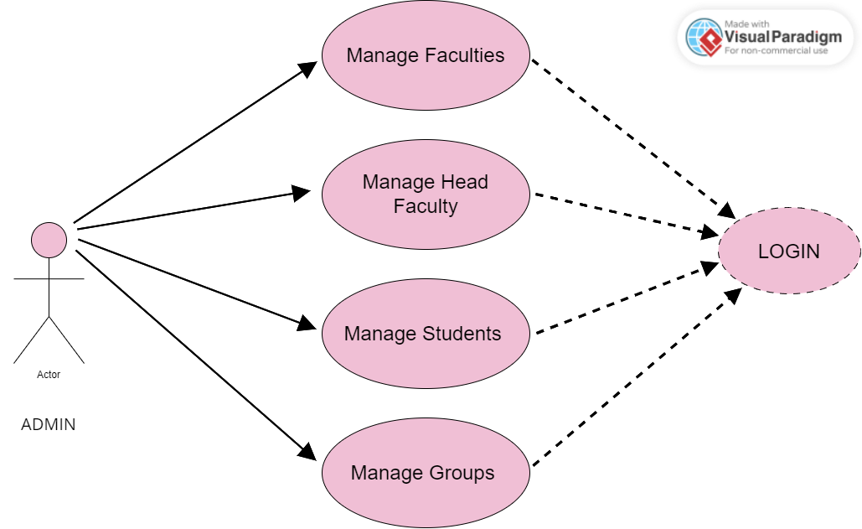

**Faculty**

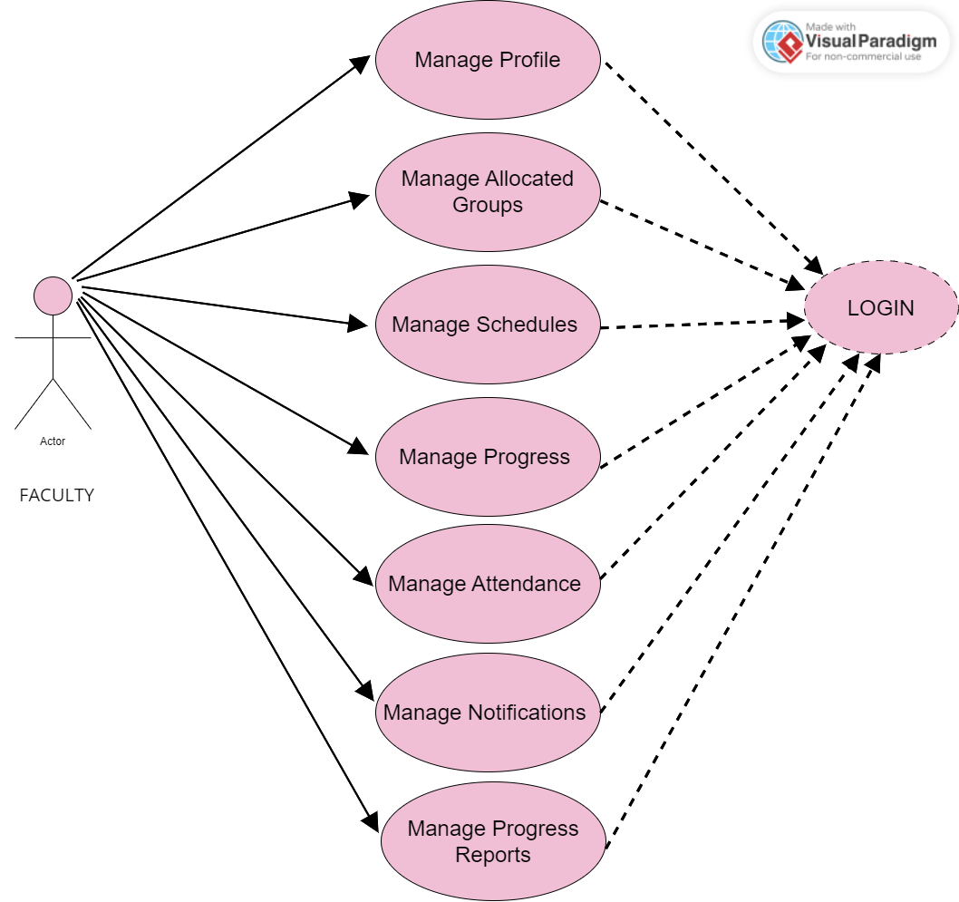

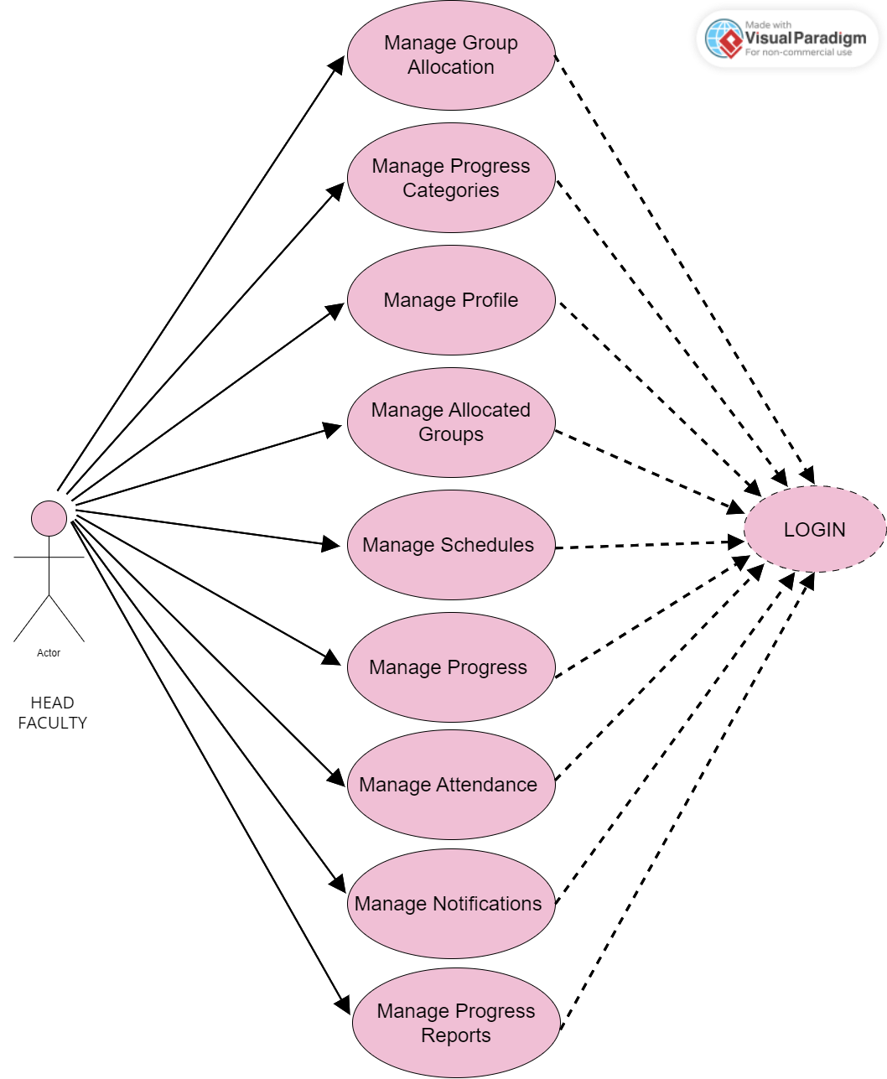

**Head Faculty**

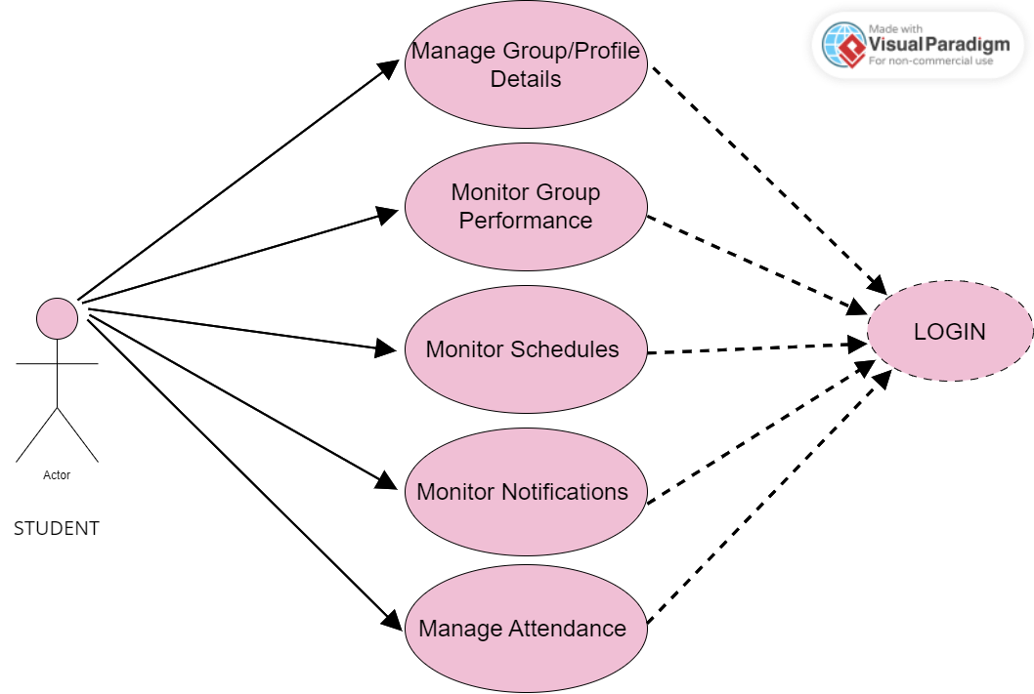

**Student**

**Data Flow Diagram**

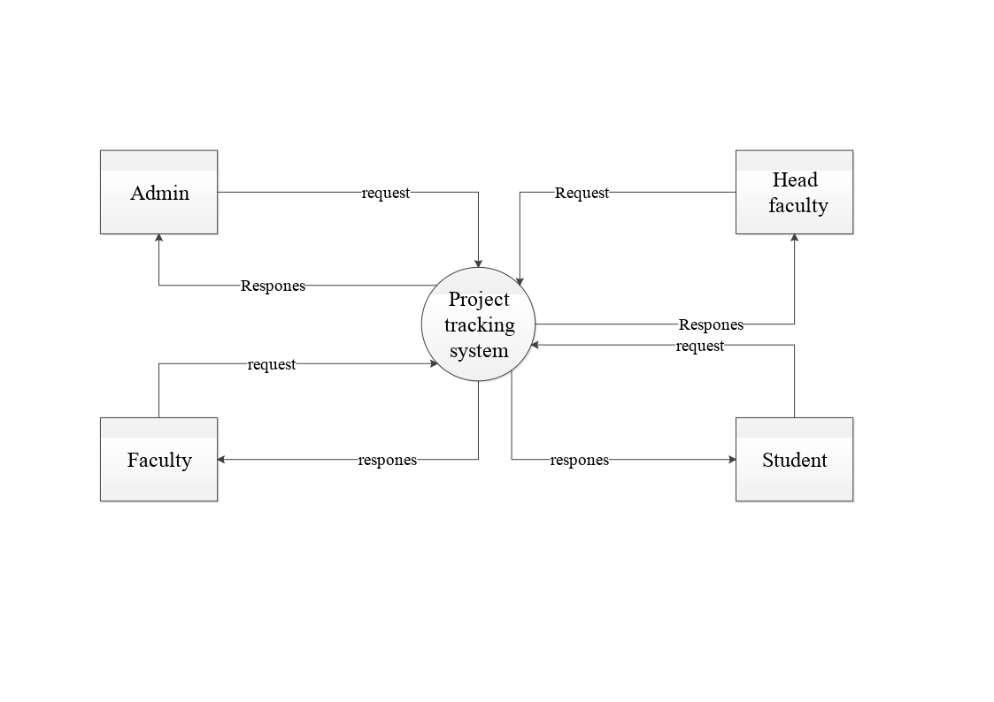**Context level DFD (0 Level)**

**Level 1 DFD Admin**

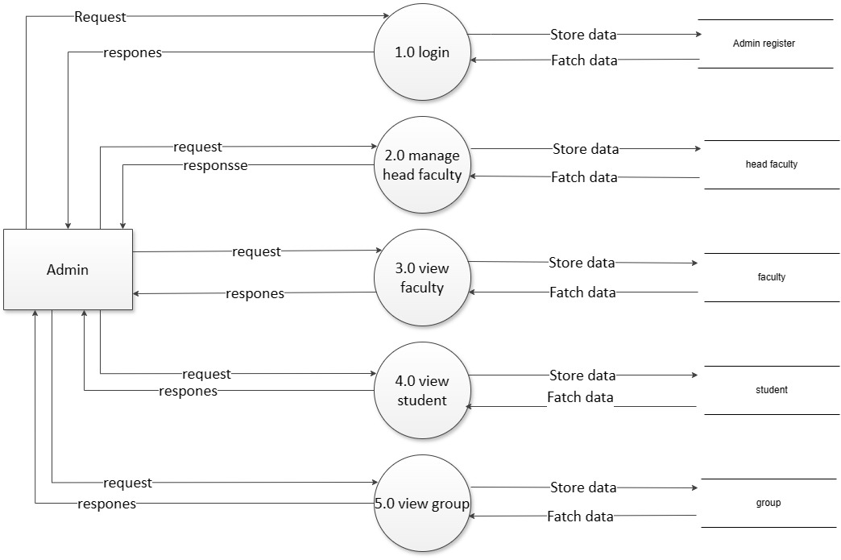



Manage faculty

Manage group details



**Level 1 DFD Faculty**

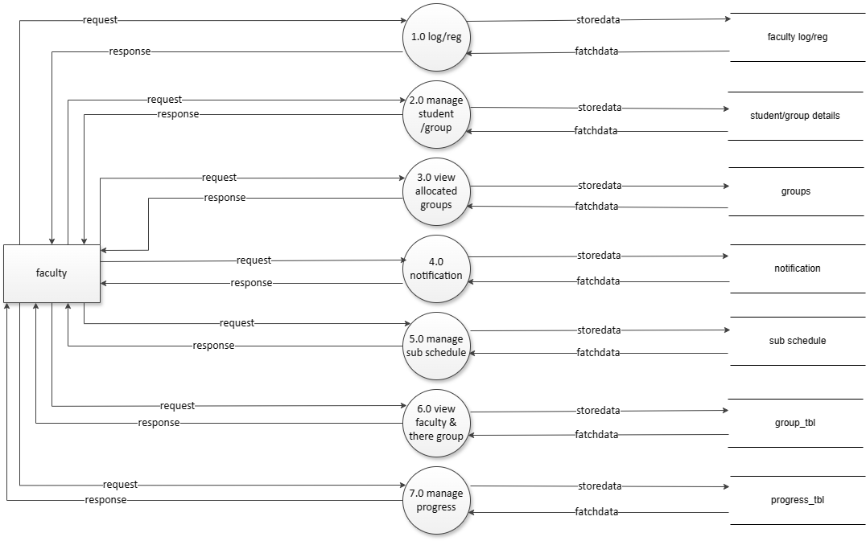

Manage attendance ?????

Generate Report ?????????

Manage schedule



**Level 1 DFD Head Faculty**

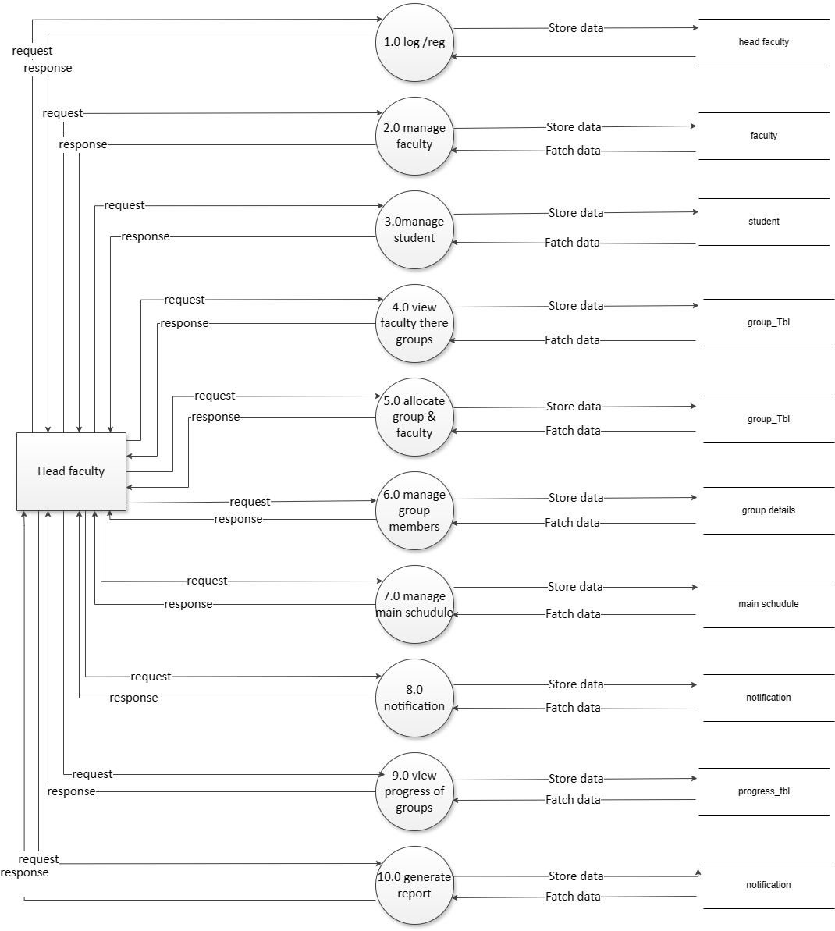



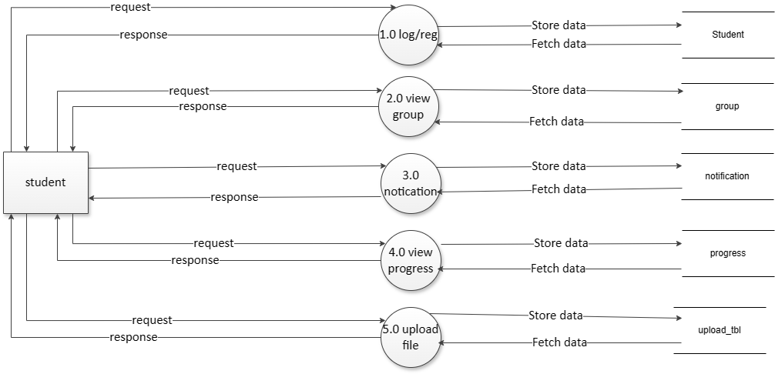**Level 1 DFD Students**

Monitor attendance



**Level 2 DFD Admin**



**Level 2 DFD Admin (Head Faculty)**

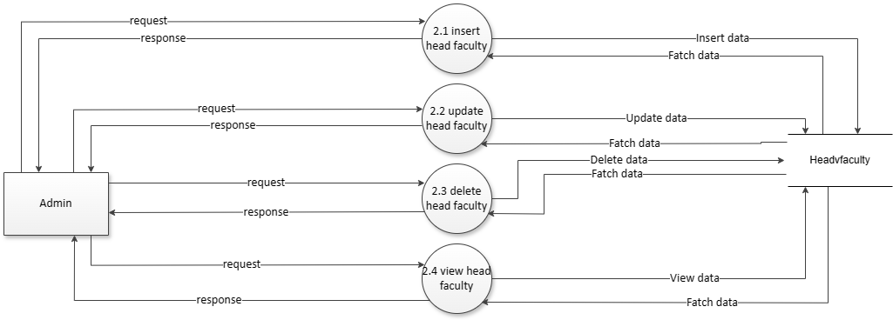



**Level 2DFD Admin (Faculty)**



Insert/update/delete/view faculty



**Level 2DFD Admin (Student)**



**Level 2 DFD Admin (Group)**



Manage Group details



**Level 2 DFD Head Faculty**



**Level 2 DFD Head Faculty (Faculty)**

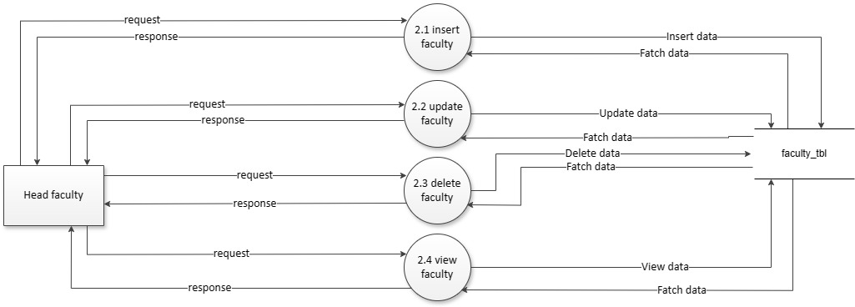



Dfd for allocate groups to faculty & change faculty for allocated group

**Level 2 DFD Head Faculty (Student)**

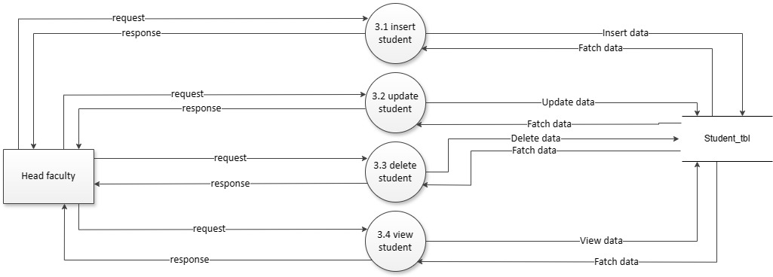



**Level 2 DFD Head Faculty (Group)**

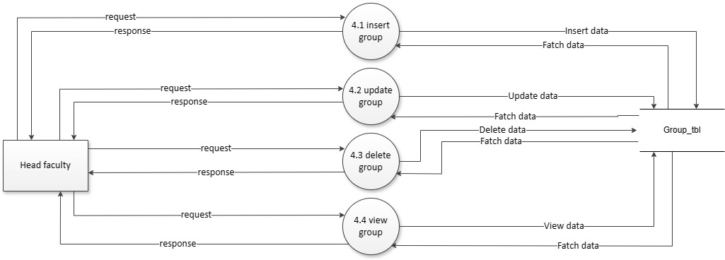

**Level 2 DFD Head Faculty (Progress)**



**Level 2 DFD Head Faculty (Notification)**







**Level 2 DFD Head Faculty (Group Details)**

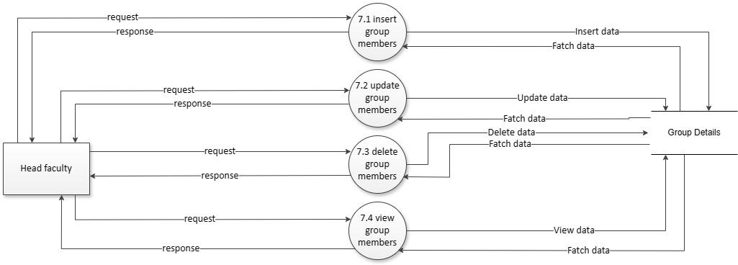

**Level 2 DFD Head Faculty (Report)**





**Level 2 DFD Faculty**



**Level 2 DFD Faculty (Group Details)**



**Level 2 DFD Faculty (Notification)**





**Level 2 DFD Faculty (Group)**





**Level 2 DFD Faculty (Sub Schedule)**

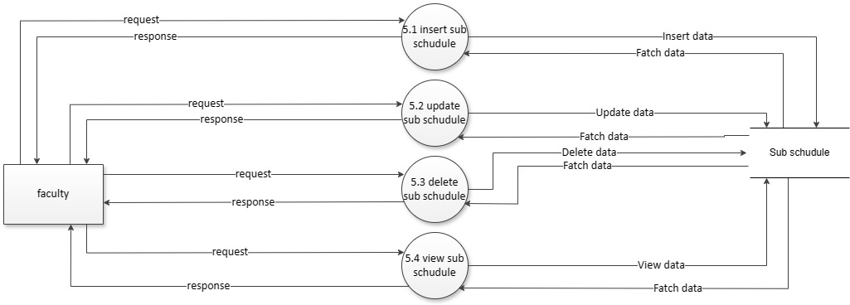



**Level 2 DFD Faculty (Progress)**

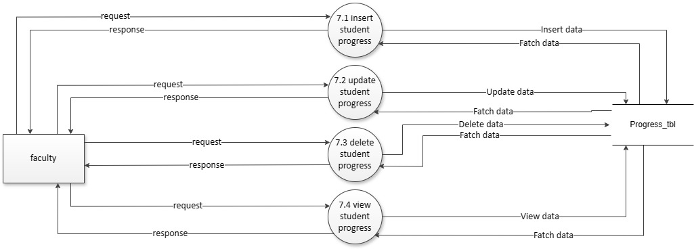

**Level 2 DFD Student**

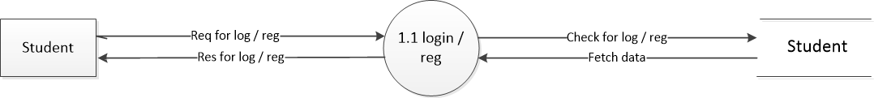

**Level 2 DFD Student (Group)**



**Level 2 DFD Student (Notification)**



Monitor Attandence???

Monitor Schedule…??

**Level 2 DFD Student (Progress)**



**Level 2 DFD Student (upload)**

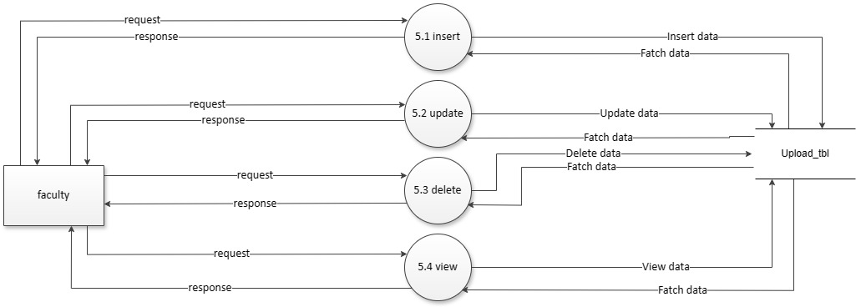



**Process Specification**

**Login Details**



**Head Faculty Details**



**Schedule Details**



**Group Progress Details**



**Group Report Details**



**Faculty Details**



**Student Group Details**



**Allocate Group Details**



**Data Dictionary**

* 1. **Login Details**

|  |  |
| --- | --- |
| Name | Login Details |
| Alias Name | None |
| Where and How Used? | * 1. Read login info(IN)   2. Verify(OUT) |
| Description | Login with following fields  aid(Primary Key) + a_name + a_pwd |

* 1. **Faculty Details**

|  |  |
| --- | --- |
| Name | Faculty Details |
| Alias Name | None |
| Where and How Used? | * 1. Insert Faculty details(IN)   2. View Faculty details (IN/OUT)   3. Update Faculty details(IN/OUT)   4. Delete Faculty details(IN/OUT) |
| Description | Faculty _id (Primary Key) + Faculty _name + Faculty_email + Faculty_phno + Faculty_image + Faculty_desc + Faculty_qualif + Faculty_exp + Faculty_address + Faculty_pwd |

* 1. **Groups Details**

|  |  |
| --- | --- |
| Name | Groups Details |
| Alias Name | None |
| Where and How Used? | * 1. Insert Groups details (IN)   2. View Groups details (IN/OUT)   3. Update Groups details(IN/OUT) |
| Description | Group_id (Primary Key) + 1st_stud_name + 1st_stud_rn + 1st_stud_div + 1st_stud_phno + 1st_stud_email + 2nd_stud_name + 2nd_stud_rn + 2nd_stud_div + 2nd_stud_phno + 2nd_stud_email + 3th_stud_name + 3th_stud_rn + 3th_stud_div + 3th_stud_phno + 3th_stud_email + 4th_stud_name + 4th_stud_rn + 4th_stud_div + 4th_stud_phno + 4th_stud_email + Image + Faculty_id ( References Fcaulty_tbl ) + group_name + pass + title + tech + status |

* 1. **Head faculty Details**

|  |  |
| --- | --- |
| Name | Head faculty Details |
| Alias Name | None |
| Where and How Used? | * 1. Insert Head faculty details(IN)   2. View Head faculty details (IN/OUT)   3. Update Head faculty details(IN/OUT)   4. Delete Head faculty details(IN/OUT) |
| Description | Headfaculty_id (PrimaryKey) + Faculty_id (References Faculty_tbl) + Headfaculty_status + headfaculty_year |

* 1. **Progress Details**

|  |  |
| --- | --- |
| Name | Progress Details |
| Alias Name | None |
| Where and How Used? | * 1. Insert Progress details(IN)   2. View Progress details (IN/OUT)   3. Update Progress details(IN/OUT)   4. Delete Progress details(IN/OUT) |
| Description | Progress_id(Primary Key) + Group_id(References group_stud_tbl) + Progress_1 + Progress_2 + Progress_3 +Progress_4 + Progress_5 + Progress_6 + Progress_7 + Progress_8 + Progress_9 + date |

* 1. **Detail Status**

|  |  |
| --- | --- |
| Name | Status Details |
| Alias Name | None |
| Where and How Used? | * 1. Read Status(OUT)   2. Update Status(IN) |
| Description | Status Checks with following fields  Status_id(PrimaryKey) + status |

* 1. **Progress Categories Details**

|  |  |
| --- | --- |
| Name | Progress part Details |
| Alias Name | None |
| Where and How Used? | * 1. Insert Progress part details(IN)   2. View Progress part details (IN/OUT) |
| Description | Progress_part_id(Primary Key) + Progress_name |

* 1. **Sub Schedule Details**

|  |  |
| --- | --- |
| Name | Sub Schedule Details |
| Alias Name | None |
| Where and How Used? | * 1. Insert Sub Schedule details(IN)   2. View Sub Schedule details (IN/OUT)   3. Update Sub Schedule details(IN/OUT)   Delete Sub Schedule details(IN/OUT) |
| Description | Sub_Schedule_id(Primary Key) + Faculty_id(References Faculty_tbl)+ Sub_weekly_date + Start Time + End Time + Sub_remark |

* 1. **Attendance Details**

|  |  |
| --- | --- |
| Name | Attendance Details |
| Alias Name | None |
| Where and How Used? | * 1. Insert attendance details(IN   2. View attendance details (IN/OUT) |
| Description | Attendance _id(PrimaryKey)+Group_id (Referncesgroup_stud_tbl) |

**Table Structures with Relationship**

1. **Admin**

|  |  |  |  |
| --- | --- | --- | --- |
| Column | Data Type | Size | Constraint |
| aid | Int | 11 | Primary key |
| a_name | Varchar | 20 | Not Null |
| a_pwd | Varchar | 200 | Not Null |

1. **Faculty**

|  |  |  |  |
| --- | --- | --- | --- |
| Column | Data Type | Size | Constraint |
| fid | Int | 11 | Primary key |
| f_name | Varchar | 50 | Not Null |
| f_email | Varchar | 50 | Not Null |
| f_phno | Big int | 20 | Null |
| f_img | Varchar | 1000 | Default man.jpg |
| f_desc | Varchar | 50 | Null |
| f_qualif | Varchar | 20 | Null |
| f_exp | Varchar | 50 | Null |
| f_address | Varchar | 100 | Null |
| f_pwd | Varchar | 500 | Not Null |

1. **Student Group**

|  |  |  |  |
| --- | --- | --- | --- |
| Column | Data Type | Size | Constraint |
| gsid | Int | 11 | Primary key |
| name1 | Varchar | 255 | Not Null |
| rn1 | Varchar | 255 | Not Null |
| div1 | Varchar | 255 | Not Null |
| phno1 | Varchar | 255 | Not Null |
| email1 | Varchar | 255 | Not Null |
| name2 | Varchar | 255 | Null |
| rn2 | Varchar | 255 | Null |
| div2 | Varchar | 255 | Null |
| phno2 | Varchar | 255 | Null |
| email2 | Varchar | 255 | Null |
| name3 | Varchar | 255 | Null |
| rn3 | Varchar | 255 | Null |
| div3 | Varchar | 255 | Null |
| phno3 | Varchar | 255 | Null |
| email3 | Varchar | 255 | Null |
| name4 | Varchar | 255 | Null |
| rn4 | Varchar | 255 | Null |
| div4 | Varchar | 255 | Null |
| phno4 | Varchar | 255 | Null |
| email4 | Varchar | 255 | Null |
| image | Varchar | 255 | Default image1.jpg |
| faculty_id | Int | 11 | References faculty_tbl |
| Group_name | Varchar | 255 | Unique |
| pass | Varchar | 255 | NotNull |
| title | Varchar | 255 | Null |
| tech | Varchar | 255 | Null |
| status | Int | 11 | Default 0 |

1. **Head Faculty**

|  |  |  |  |
| --- | --- | --- | --- |
| Column | Data Type | Size | Constraint |
| hid | Int | 11 | Primary key |
| fid | Int | 11 | Foreign key (faculty_tbl) |
| h_status | Int | 2 | Default 0 |
| h_year | Int | 4 | Year() |

1. **Progress part**

|  |  |  |  |
| --- | --- | --- | --- |
| Column | Data Type | Size | Constraint |
| id | Int | 11 | Primary key |
| pro_name | Varchar | 100 | Not Null |

1. **Student Details Status**

|  |  |  |  |
| --- | --- | --- | --- |
| Column | Data Type | Size | Constraint |
| Status_ id | Int | 11 | Primary key |
| status | Int | 11 | Default 0 |

1. **Progress**

|  |  |  |  |
| --- | --- | --- | --- |
| Column | Data Type | Size | Constraint |
| proid | Int | 11 | Primary key |
| grpid | Int | 11 | References (Group_stud_tbl) |
| P1 | Int | 11 | Not Null |
| P2 | Int | 11 | Not Null |
| P3 | Int | 11 | Not Null |
| P4 | Int | 11 | Not Null |
| P5 | Int | 11 | Not Null |
| P6 | Int | 11 | Not Null |
| P7 | Int | 11 | Not Null |
| P8 | Int | 11 | Not Null |
| P9 | Int | 11 | Not Null |
| date | Int | 11 | Today(‘Y-m-d’) |

1. **Schedule**

|  |  |  |  |
| --- | --- | --- | --- |
| Column | Data Type | Size | Constraint |
| subid | Int | 11 | Primary key |
| fid | Int | 11 | Null |
| sub_weekly_date | Date | - | Null |
| sub_remark | Varchar | 300 | Null |
| sub_start_date | Time | - | Null |
| sub_end_date | Time | - | Null |

1. **Attendance**

|  |  |  |  |
| --- | --- | --- | --- |
| Column | Data Type | Size | Constraint |
| aid | Int | 11 | Primary key |
| gid | Int | 11 | Foreign key (Group_stud_tbl) |

**7.**

**Design Report**

## Site Diagram/Program Flow Diagram



**Algorithms/Flow Chart**



## Security issues

* In the system there are some security issues in hacking side and in other fields like database related issues and CSS related issues too.
* The hacker can easily hack the system and down server for users.

* The files which is stored on the server there may be chances for stolen or corrupted from server and not available for long last.
* The system is not providing high level of security so the data is may beat risk in the future.
* The system is easy to understand and provide low level of security tool sand interfaces so it is easily hack able by well practice hackers.

## Input Screen Layouts

**8.**

**Testing Report**

**Testing Report**

* 1. **Test Case Design**

**TEST CASE 1: LOGIN VERIFICATION**

1.1 ADMIN LOGIN

|  |  |  |  |
| --- | --- | --- | --- |
| Sr no. | Field Name | Invalid | Valid |
| 1. | a_name | anything_id | admin |
| 2. | a_pwd | anything_pwd | tiger |

1.1 FACULTY LOGIN

|  |  |  |  |
| --- | --- | --- | --- |
| Sr no. | Field Name | Invalid | Valid |
| 1. | f_name | dipamrami | Dipam Rami |
| 2. | f_pwd | DIPAM123 | Dipam123 |

1.1 STUDENT GROUP LOGIN

|  |  |  |  |
| --- | --- | --- | --- |
| Sr no. | Field Name | Invalid | Valid |
| 1. | group_name | Abc01 | Group01 |
| 2. | Pass | anything | group01123 |

**TEST CASE 2: FACULTY DETAILS VERIFICATION**

|  |  |  |  |
| --- | --- | --- | --- |
| Sr no. | Field Name | Invalid | Valid |
| 1. | f _name | Dipam123 | Dipam Rami |
| 2. | f_email | Dipam.org | dipamrami@gmail.com |
| 3. | f_phno | 41524 | 5462158741 |
| 4. | f_img | pro.webp/pro2.pdf | pro2.jpg/pro2.jpeg |
| 5. | f_desc | Null | Asst. Prof. |
| 6. | f_qualif | Abc | Msc. IT |
| 7. | f_exp | Five | 5 |
| 8. | f_address | Null& anything% | Sai sardar Socity,Surat |
| 9. | f_pwd | 123 | dipam123 |

**TEST CASE 3: GROUP REGISTRATION VERIFICATION**

|  |  |  |  |
| --- | --- | --- | --- |
| Sr no. | Field Name | Invalid | Valid |
| 1. | name1 | Jay123/null | Jay Sopariwala |
| 2. | rn1 | 22/null | 5322 |
| 3. | div1 | 1/null | TY DIV-1 |
| 4. | phno1 | 415235/null | 7041818776 |
| 5. | email1 | Jay&.com | jaysopari29@gmail.com |
| 6. | name2 | Ram111 | Ram / Null |
| 7. | rn2 | 14 | 5314 / Null |
| 8. | div2 | 2 | TY DIV-2 / Null |
| 9. | phno2 | 6541615648451621 | 2345612350 / Null |
| 10. | email2 | Ram1.in | [ram3@yahoo.com](mailto:ram3@yahoo.com) / Null |
| 11. | name3 | Shradhha_1 | Shradhha Kapoor / Null |
| 12. | rn3 | 97 | 5297 / Null |
| 13. | div3 | 1 | TY DIV-1 / Null |
| 14. | phno3 | +91 564664 | 5544771235 / Null |
| 15. | email3 | Sradhayahoo.in | [kshradhha@gmail.com](mailto:kshradhha@gmail.com) / Null |
| 16. | name4 | Jhons_jemi | Jhons jemi / Null |
| 17. | rn4 | 45 | 9245 / Null |
| 18. | div4 | 4 | TY DIV-4 / Null |
| 19. | phno4 | 745264 | 4512687428 / Null |
| 20. | email4 | jhononly | [Johnjemi@outlook.com](mailto:Johnjemi@outlook.com) / Null |
| 21. | Image | Img1.webp/image2.pdf | Img1.jpg/ image1.jpeg / Null |
| 22. | group_name | Group#$1 /null | Group01 |
| 23. | Pass | Abc / null | Group01123 |
| 24. | Title | Progress%pilot / null | Progress Pilot |
| 25. | Tech | anything/null | Mobile - Web Application |

**TEST CASE 4: SCHEDULE VERIFICATION**

|  |  |  |  |
| --- | --- | --- | --- |
| Sr no. | Field Name | Invalid | Valid |
| 1. | weekly_date | Back date | Today’s date / upcoming date |
| 2. | start_time | 05:00 AM | Between 7:30 AM To 3:00 PM |
| 3. | end_time | 05:00 PM | Between 8:00 AM To 4:00 PM |
| 4. | schedule_title | Null | Scheulde for Group N |

**Testing Issues**

* **Integration Testing:**

Integration testing is a systematic technique for constructing the program structure while conducting test to uncover errors associated with interfacing. The objective is to take unit tested module and build a program structure that has been dictated by design

After our individual modules were tested out we go to the integrated to create a complete project. This integration process involves building the software and testing the e progress tracking software for problems that arise from component interactions.

* **Black Box Testing:**

As s/w functions are operational, the set of input conditions. Exercising all functional requirements will be derived to uncover the different class of the behavioural errors such as incorrect functions, incorrect interfaces, external data structure errors, performance errors and termination errors

* **White Box Testing:**

Based on the control structure of the procedural design, the logical paths are been exercised with specific set of conditions, loops at boundaries to examine the validity of the internal data structures.

* **Alpha Testing:**

The development site, the students conducts an alpha test under the Natural settings to record the errors and usage problems.

* **Beta Testing:**

At the student site, the end-user(students) conducts the “live” application test user environment to encounter the problems to be modified before Product release.

* **System Testing:**

As the s/w is to be integrated with other system elements, system testing focuses on validating the system integration by,

* + - Recovery Testing: To assure proper recovery
    - Security Testing: To protect the improper penetration
    - Stress Testing: To confront the program with abnormal resources such as quantity, frequency or volume.

The purpose of stress testing is to identify the breaking points or weaknesses in the system so that they can be addressed before the system is deployed in a production environment.

1. Quantity: Increasing the number of concurrent users, transactions, or data inputs beyond normal levels.

2. Frequency: Introducing high-frequency requests or events to the system to simulate peak usage periods.

3. Volume: Injecting large amounts of data or traffic into the system to assess its performance under heavy loads.

* A test case has a component that describes an input, action, or event and an expected response, to determine if a feature of an application is working correctly. Various test cases for this web application are tested on different browsers. (Google chrome, Mozilla Firefox) and the Mobile applications are tested on different Os& Smart Devices (Samsung's One UI, Xiaomi's MIUI, Oppo's Color OS, Vivo's Fun touch OS)

**9.**

**Limitation of Purpose System**

## Limitation of Purpose System

* **The web/app-based application has following limitations:**
* The system has not any mechanism for separating individual student information in another table to manage student information individually.
* The system has not mechanism for adding or removing any progress categories.
* The system is hosted on the server, so we have 24-hour internet connection.
* The system is working on the server so validate data should be entered in database. If admin would not knowledgeable so data in the database are inadequate and it was worthless.
* The hacker can easily hack the system and gets server down and then the important data are corrupted.
* If internet and electricity is improper then system can’t be access properly.
* If the user is not aware with the system, then the purpose for making the system is worth Less.

**10.**

# **Future Enhancement**

## Future Enhancement

### .

* Firstly, we will can introduced separate database table for managing individual student details.
* We will can also provide seminar progress management in this system as well.
* We will can also provide additional functionality in chatting module to share project related images and files etc. between faculty to students that helps both to easily communicate over the network.
* We will can also introduced a new module, that contains formal students project & documentation demos that helps current students how to develop their projects, documentation and how they can take ideas from formal projects to redeveloped innovative things in their projects.
* We can make the system more user-friendly means the interfaces can more advanced level and high compatibility.
* We can add multiple level security and uses the high technology for reducing security issues and make system stronger.
* We can improve user interface elements and controls and validating methods for better performance of the system.
* In advance, we can merge collage management system, library management system and other related functionalities.

# **11.**

**Justification of System as MIS and DSS**

## Justification of System as MIS and DSS

* Progress Pilot is a Management Information System. The product provides various interfaces to manage all the details of FACULTIES, STUDENTS GROUPS, GROUP PROGRESS,PROGRESS CATEGORIES, SCHEDULES which are managed by the Administrator and Faculties who keeps track of all the activities.
* Necessary Progress Reports are generated as per the ADMIN & FACULTIES requirement to provide information more efficiently to the external supervisor.
* So, we can categorize the system as MIS. As a system in MIS it can be Decision Support System, which helps in taking decisions.

**12.**

# **References**

**References**

* Web site Design Template
* <https://www.thememakker.com/template/oreo-university-bootstrap4-admin/>
* Mobile Application UI Design
* <https://www.behance.net/gallery/126905093/Taskio-Project-management-app-ui-ux-design>
* <https://www.behance.net/gallery/188253237/Project-Management-App?tracking_source=search_projects|project+management+flutter+app&l=14>
* For more additional Research& Error solving
* <https://stackoverflow.com/> (Stack overflow)
* <https://www.google.com/> (Google)
* <https://chat.openai.com/> (Chat Gpt open Ai)